1、Double click to open the exe. file
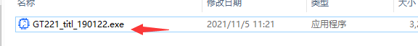

2、Click "Connect"
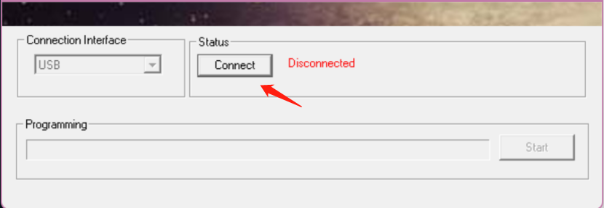

- Connect the pen display or pen tablet to your computer, then you can see ”Connected”.
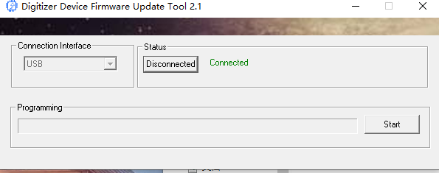

4、Click "Start"，the program will be automatically upgraded，then you can see pop-up ”Programming flash,OK!”
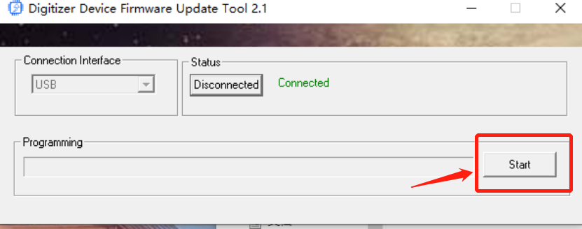
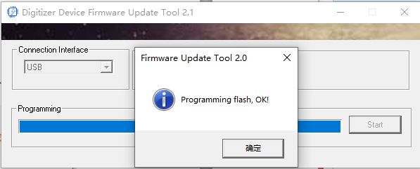

5、Close the software, reconnect the pen display or pen tablet to your computer, then the upgrade is complete.

